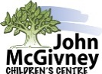
The John McGivney Children’s Centre
3945 Matchette Road
Windsor, Ontario N9C 4C2
T: 519.252.7281
Toll Free: 1.866.636.6666
F: 519.252.5873
www.jmccentre.ca
TEEN Life Skills Application Form

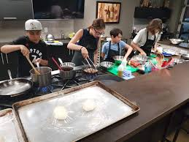
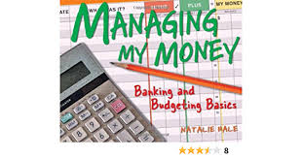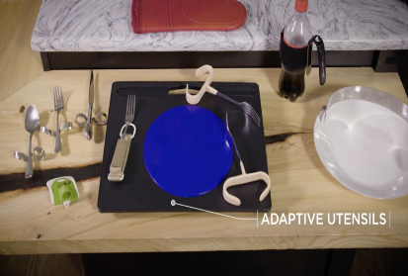
JMCC is excited to be offering a Life Skills Building program this summer for teens aged 14- 21 years old. Past and present JMCC clients are welcome to apply. Activities will focus on education, making social connects and opportunities to put what is taught into practice in preparation for real life. Space is limited, only 6 participants for each session so register early! Everyone that applies will be contacted to confirm if they have a spot.
Eligibility Criteria
- High school (graduated from grade 8)
- Use of some extremities or ability to direct your own care
- Able to tolerate hand-over-hand assistance & close proximity of helpers as needed
- Able to attend without personal care support
- Ability to follow 2-step instructions
- Ability to communicate your own learning goals for the program
- Ability to participate in a group setting
There will be two program options. All groups will be interactive, fun and will provide opportunities to connect with other teens
- Option A: Sessions will be from 1:30 pm to 3:30pm at JMCC. Teens can register for any sessions that they would like to attend based on skills that they would like to work on.

  - July 11 - Budgeting Skills: (18- 21 years) Learn to prepare a budget in preparation for living on your own
  - July 12 - Budgeting Skills: (14- 17 year) Learn basic building blocks to successfully manage a budget
  - July 13 - Meal Planning and Preparation: Learn how to prepare a simple meal and share with friends!
  - July 14 - Self-Care: Try adaptive aides to help with independence with personal care. Learn strategies for coping with stress and anxiety using mindfulness, healthy nutrition and fitness options
  - July 15 - Self Advocacy: Finding your voice and building your confidence to speak up for yourself

- Option B: Sessions will be from 1:30 to 3:30pm at JMCC. For this option, teens must attend all 5 sessions. Each session will build on the previous sessions.
July 18 - Meal Preparation and Budgeting: Learn to budget, shop and plan out a meal
July 19 - Cooking and Independent Eating: Try out adaptive aides to prepare a meal to enjoy with friends!
July 20 - Organization Skills and Building a Routine: Learn how to do laundry, organize your wardrobe, time management skills and more
July 21 - Self-Care: Try adaptive aides to help with independence with personal care. Learn strategies for coping with stress and anxiety using mindfulness, healthy nutrition and fitness options
July 22 - Self Advocacy: Finding your voice and building your confidence to speak up for yourself

PERSONAL INFORMATION

Your Name: Click or tap here to enter text.

DOB: Click or tap here to enter text. Age: Click or tap here to enter text.

Name of Parent/Guardian: Click or tap here to enter text.

Phone: Home: Click or tap here to enter text. Work: Click or tap here to enter text.

Email address: Click or tap here to enter text.

In case of emergency contact: (name and phone) Click or tap here to enter text.

Programs you are registering for:

Option A (please check off the ones you wish to attend)

☐July 11 - Budgeting Skills (18- 21 years old)
☐July 12 - Budgeting Skills (14- 17 year old
☐July 13 - Meal Planning and Preparation
☐July 14 - Self-Care
☐July 15 - Self Advocacy

Option B (you must be able to attend each session)

☐July 18-22
Communication
How do you communicate:
☒ communication device
☐ verbal
☐ sign language

In your own words, please briefly describe what you would like to learn by attending the sessions(s) you selected

Click or tap here to enter text.

Please register by June 24 2022

For any questions, please contact Wendy Tavares at 519-252-7281 ext. 242 or wendy.tavares@jmccentre.ca

