What is heavy work?
- Heavy work means moving your body against resistance which activates proprioceptive receptors in your muscles, tendons or joints

Why is heavy work important?
- This system helps us understand where our body is in space (e.g. tying shoes without looking)
- It also tells us how much force we are using and whether we need to use more or less force in order to successfully complete a task (e.g. when colouring, cutting our food or opening/closing a door)
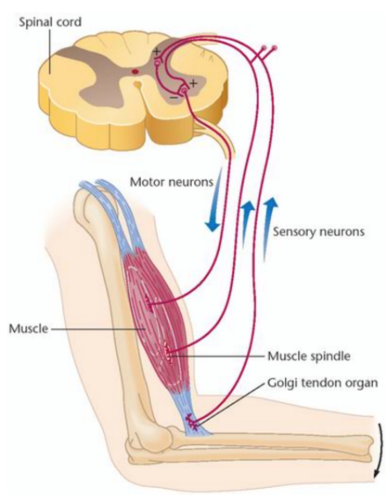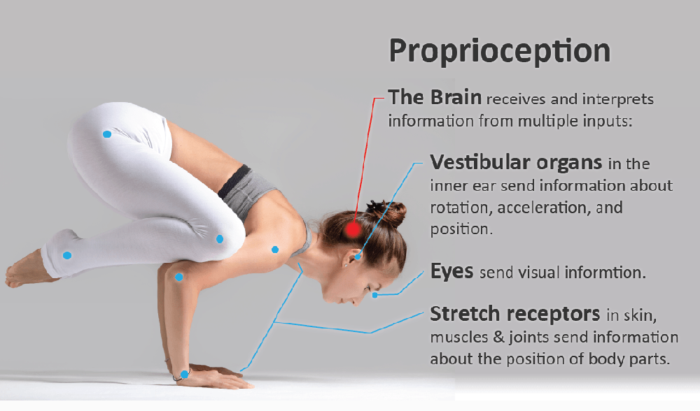

How does heavy work help students?
- The resistive input obtained through heavy work activities generally has a calming or organizing effect
- It allows children to improve their arousal level to a state where they can pay attention and learn
- Proprioceptive input also helps to improve body awareness which helps with overall coordination

How to incorporate heavy work into the classroom?
- The best activities are the ones that can be easily incorporated into daily routines and are enjoyed by the students; try a few of the following and see what works best:

- Pushing/Pulling Activities:
  - Pushing a cart down the hall (weighted with book, recycling, snacks etc)
  - Singing “row, row, row your boat” with a partner by sitting on the floor, holding hands, pushing and pulling each other
  - Try to stand up with a partner by sitting back to back, interlocking arms, placing feet flat on the floor and pushing against each other into standing
  - Doing full or knee push-ups or wall push-ups or crawling activities
  - Pulling friends outside in a wagon or sled
  - Playing in a hands-and-knee position or lying on tummy while reading or doing homework
  - Pushing and holding open heavy doors

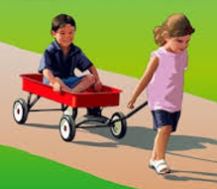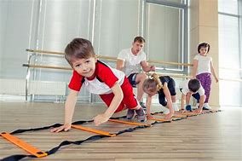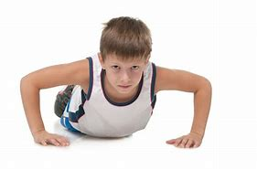

- Squeezing:
  - Playing with resistive putty or play-doh while incorporating tools such as scissors, rolling pins, cookie cutters and stamps
  - Cutting out items from thick cardstock paper

- Lifting/Carrying:
  - Lifting or taking down chairs
  - Helping to rearrange desks in the classroom
  - Erasing chalk or dry erase board
  - Carrying bins full of recycling or books
  - Helping around the school, carrying and stacking books, printer paper or supplies
  - Carrying a heavy backpack (wearing one even when not needed)
  - Setting up/ putting away gym supplies ex. hanging mats on the wall, lifting balls into storage bins, hanging rings over post, etc.

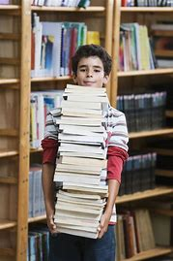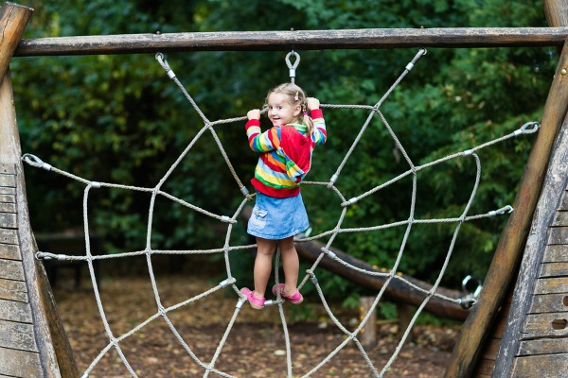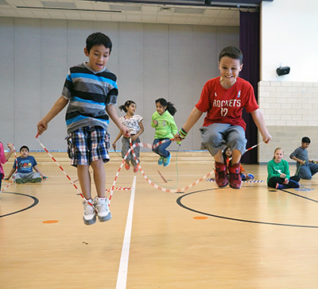

- Climbing:
  - Most easily done at a play structure with ladders, rock wall and monkey bars or climbing area
  - Going up and down stairs

- Jumping/Running:
  - Play jumping games like hopscotch or jump rope
  - Sitting and bouncing on a hippity hop ball
  - Jumping in and out of hoops or hopping on one foot
  - Galloping or skipping in gym
  - Most sports (e.g. soccer, basketball, flag football, gymnastics, ball hockey, volleyball, etc)

- Chewing/Sucking/Blowing:
  - Allow gum chewing
  - Provide chewy snacks/candy for rewards (licorice, fruit roll-ups, tootsie rolls, starburst)
  - Offer crunchy foods for class snacks (carrots, celery, apples, pears, pretzels, popcorn)

